**Week 10**

**Functions, Execution Context and the Call Stack**

The JavaScript codes when executed create one global context and it executed one thing by time, normally the top to bottom

Functions are code blocks that perform a task and can be reusable, can have parameters, and return something. When a function declaration is done this stays salve in global memory when the function is called it's going to call stack.

Call Stack is responsible to stack each called function that appears in a global context then the function is executed, and your result is storage and execute in local context.

When performing a debug in the application, it is possible to monitor the execution context, the scope of the variables/functions and the call stack.

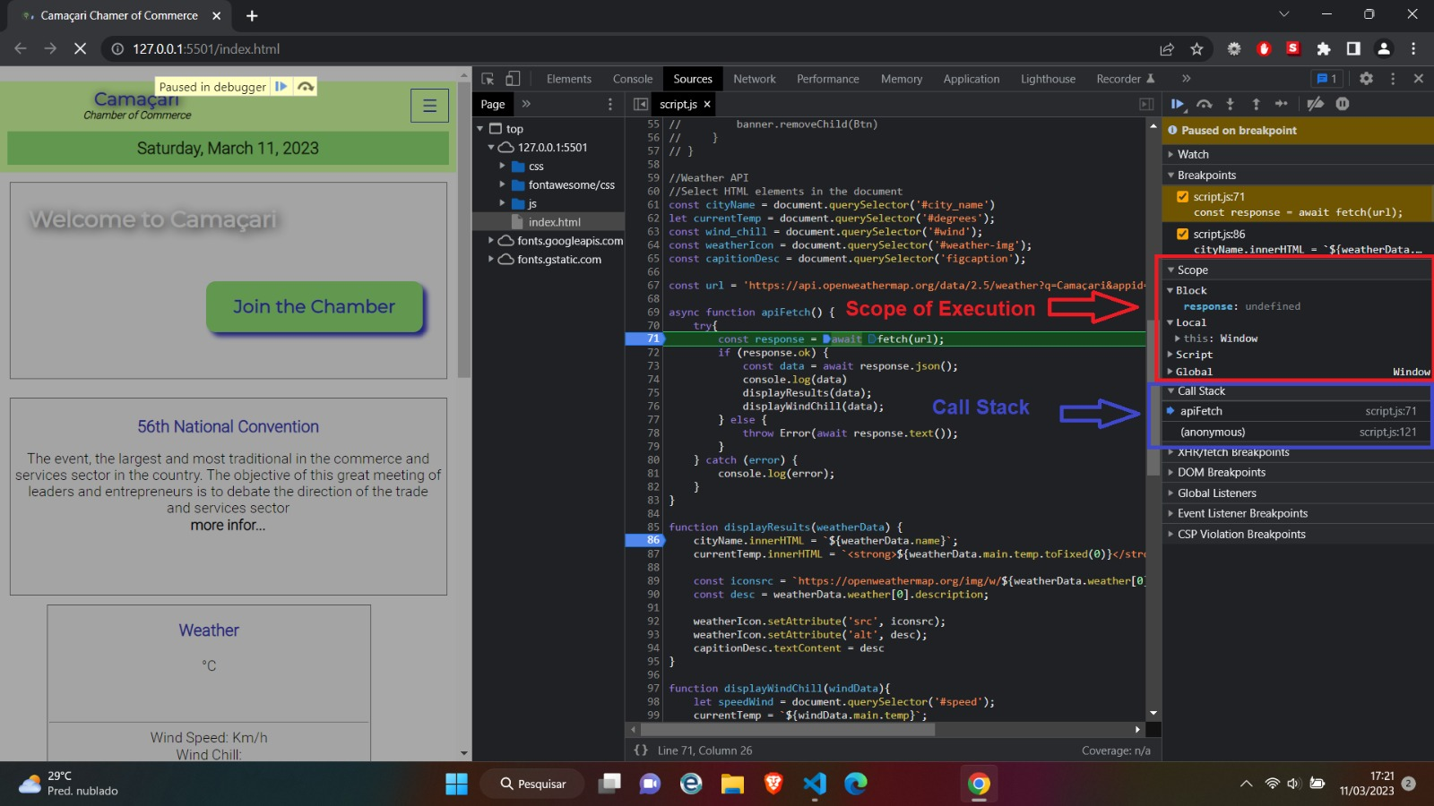

**Callbacks & Higher Order Functions**

Higher-order functions are functions that take one or more functions as arguments, returning another function and callbacks are arguments of a high-order function, the execution of a callback is called from within the high-order function to resume the flow of execution.

